UNEARTHING THE ENVIRONMENTAL IMPACT OF HUMAN ACTIVITY: A GLOBAL CO2 EMISSION ANALYSIS

INTRODUCTION:

Carbon dioxide emissions are emissions stemming from the burning of fossil fuels and the manufacture of cement. They include carbon dioxide produced during the combustion of coal, oil, natural gas, and other petroleum products for energy production, as well as emissions from industrial processes such as the production of iron and steel, cement, and other materials have all contributed to the dramatic increase in atmospheric carbon dioxide levels over the past two centuries. This has caused global temperatures to rise, leading to climate change and its associated impacts on ecosystems, weather patterns, and human health. Carbon dioxide in the atmosphere warms the planet causing climate change. Human activities have raised the atmospheric carbon dioxide content by 50% in less than 200 years

PROBLEM DEFINITION AND DESIGN THINKING:

An empathy map is a collaborative tool teams can use to gain a deeper insight into their customers. Much like a user persona, an empathy map can represent a group of users, such as a customer segment. The empathy map was originally created by Dave Gray and has gained much popularity within the agile community.

RESULT:

IMAGE OF DASHBOARD:

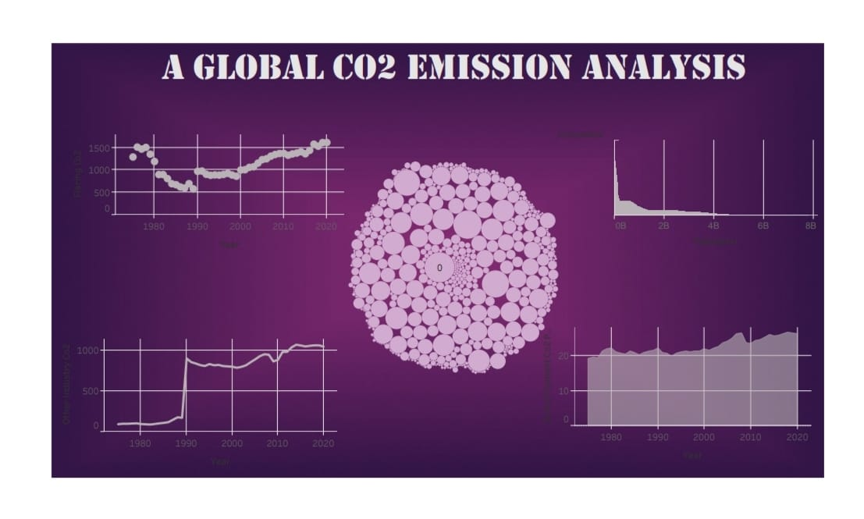

Cement CO2 emission:

China is the highest cement CO2 emitting country in the world.

Brazil is the country that emits the lowest amount of CO2 per ton of cement produced in the world.

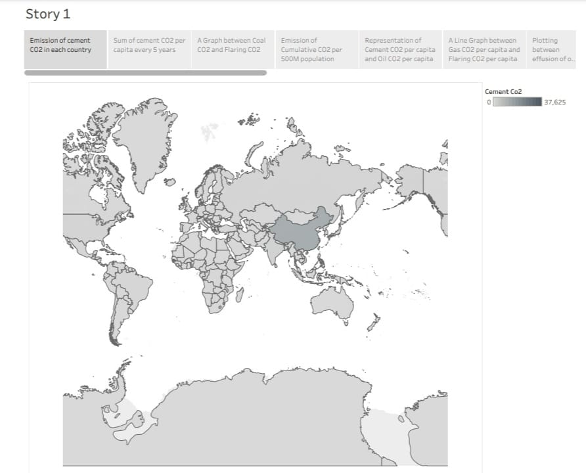

Flaring CO2 emission:

Asia is the highest amount of flaring CO2 emitting countries.

The highest emission of flaring CO2 of 1,613 ppm occurred in the year 2020.

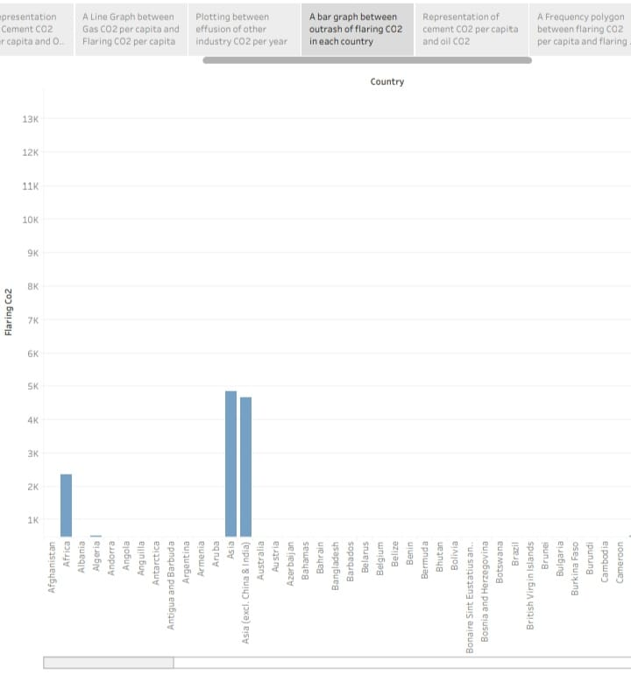

Coal CO2 emission:

China is the world's largest emitter of carbon dioxide emissions from coal combustion by far.

Other industry CO2:

Other industry (10.6%): energy-related emissions from manufacturing in other industries including mining and quarrying, construction, textiles, wood products, and transport equipment (such as car manufacturing)

The lowest effusion of other industry CO2 was recorded in the year 1982 and on the other hand the highest effusion of other industry CO2 was recorded in the year 2014.

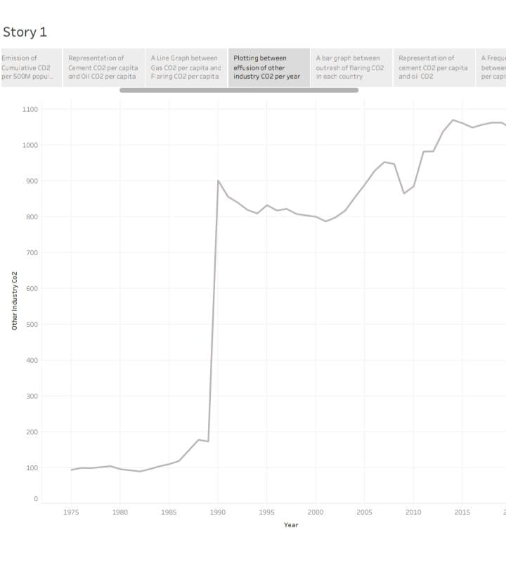

ADVANTAGES AND DISADVANTAGES:

Advantages of CO2:

* Carbon dioxide is an essential component of our atmosphere, playing a vital role in regulating the temperature of our planet. Without it, the Earth would be much colder than it is today, making it difficult for life to exist. Carbon dioxide acts as a greenhouse gas, trapping heat from the sun and preventing.
* Carbon dioxide is an absolutely essential component of our atmosphere, playing a critical role in maintaining the temperature of our planet. Without it, the earth would be much colder than it is today, making it virtually impossible for life to exist. Carbon dioxide acts as a powerful greenhouse gas, trapping heat from the sun and helping to keep our planet warm enough for us to survive. Without it, the earth would be a much colder and inhospitable place.

Disadvantages of CO2 :

* Carbon emissions are dangerous in that they threaten the livelihood of our planet, animals, humans, and ultimately, life as we know it. The amount of carbon emissions trapped in our atmosphere causes global warming, which causes climate change, symptoms of which include melting of the polar ice caps, the rising of sea levels, the disturbance of animals’ natural habitats, extreme weather events, and so many more negative side effects that are dangerous to the planet, to human and animal life, and to our future.
* Due to its molecular structure, CO2 absorbs and emits infrared radiation trapping heat and this is the core reason for climate change. Extreme weather, food supply disruptions, and increased wildfires are other effects of climate change caused by high CO2 and other greenhouse gases.
* Human and animal health affected by high CO2 levels
* Heat Waves – Already the deadliest extreme weather type, an increase in CO2 directly leads to increased Earth temperatures. The hotter it gets, the tougher it will be to survive. Pollution – Pollution currently kills 9 million people per year.
* Cause respiratory diseases to humans
* Carbon emissions affect human life directly by causing more respiratory complications due to the increase in air pollution. Even worse, carbon emissions kill some animal species and destroy food, which highly affects humans.

APPLICATIONS OF CO2:

* Multi-Industry Uses for Carbon Dioxide (CO2):

Carbon dioxide in solid and in liquid form is used for refrigeration and cooling. It is used as an inert gas in chemical processes, in the storage of carbon powder and in fire extinguishers.

* Manufacturing and Construction Uses:

Carbon dioxide is used on a large scale as a shield gas in MIG/MAG welding, where the gas protects the weld puddle against oxidation by the surrounding air. A mixture of argon and carbon dioxide is commonly used today to achieve a higher welding rate and reduce the need for post weld treatment.

* Dry ice pellets are used to replace sandblasting when removing paint from surfaces. It aids in reducing the cost of disposal and cleanup.

Chemicals, Pharmaceuticals and Petroleum Industry Uses:

* Large quantities are used as a raw material in the chemical process industry, especially for methanol and urea production.

Carbon dioxide is used in oil wells for oil extraction and to maintain pressure within a formation.. When CO2 is pumped into an oil well, it is partially dissolved into the oil, rendering it less viscous, allowing the oil to be extracted more easily from the bedrock. Considerably more oil can be extracted from through this process.

* Rubber and Plastics Industry Uses:
* Flash is removed from rubber objects by tumbling them with crushed dry ice in a rotating drum.
* Food and Beverages Uses for Carbon Dioxide:
* Liquid or solid carbon dioxide is used for quick freezing, surface freezing, chilling and refrigeration in the transport of foods. In cryogenic tunnel and spiral freezers, high pressure liquid CO2 is injected through nozzles that convert it to a mixture of CO2 gas and dry ice "snow" that covers the surface of the food product. As it sublimates (goes directly from solid to gas states) refrigeration is transferred to the product.
* Carbon dioxide gas is used to carbonate soft drinks, beers and wine and to prevent fungal and bacterial growth.
* Liquid carbon dioxide is a good solvent for many organic compounds. It is used to de-caffeinate coffee.
* It is used as an inert “blanket”, as a product-dispensing propellant and an extraction agent. It can also be used to displace air during canning.
* Supercritical CO2 extraction coupled with a fractional separation technique is used by producers of flavors and fragrances to separate and purify volatile flavor and fragrances concentrates.
* Cold sterilization can be carried out with a mixture of 90% carbon dioxide and 10% ethylene oxide, the carbon dioxide has a stabilizing effect on the ethylene oxide and reduces the risk of explosion.
* It is used to neutralize alkaline water.
* Miscellaneous Uses for Carbon Dioxide (CO2):
* Liquid carbon dioxide's solvent potential has been employed in some dry cleaning equipment as a substitute for conventional solvents. This use is still experimental - some types of soil are more effectively removed with traditional dry cleaning equipment, and the equipment is more expensive.
* Yields of plant products grown in greenhouses can increase by 20% by enriching the air inside the greenhouse with carbon dioxide. The target level for enrichment is typically a carbon dioxide concentration of 1000 PPM (parts per million) - or about two and a half times the level present in the atmosphere.

CONCLUSION:

All the energy we use in our homes leads to additional carbon emissions. Over half of home energy is used for heating, so it's important to make sure that the walls, roof, and floors in your home are insulated, cutting back on heat waste and reducing your carbon footprint.